COVID-19 Student Absence procedures- Help us Keep YOU and OTHERS SAFE
If you….. | What to do |  | When to come back to College?
If you feel unwell with –  A new continuous cough  Fever  Loss of taste or smell | Stay home  Get a test | 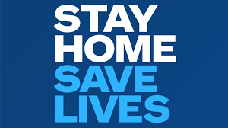 | Come back after you have a negative test  Or  come back after 14 days so long as you don’t have any symptoms
You feel unwell and are awaiting a test result | Stay home  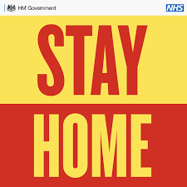 | 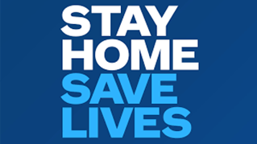 | Come back after you have a negative test  Or  come back after 14 days so long as you don’t have any symptoms
Have someone at home who tests positive with COVID-19 | Stay home for 14 days  Watch for symptoms  If you develop symptoms get a test |  | Come back after you have a negative test  Or  come back after 14 days so long as you don’t have any symptoms
Have someone at home who has gone for a test but you don’t yet know the result | Stay home. If someone in your household shows symptoms of COVID you should stay and watch for symptoms in yourself. If you develop symptoms get a test. |  | Come back after you have a negative test  Or  come back after 14 days so long as you don’t have any symptoms
Have been told by Track n Trace to isolate | Stay home for 14 days  Watch for symptoms  If you develop symptoms get a test |  | Come back after you have a negative test  Or  come back after 14 days so long as you don’t have any symptoms

